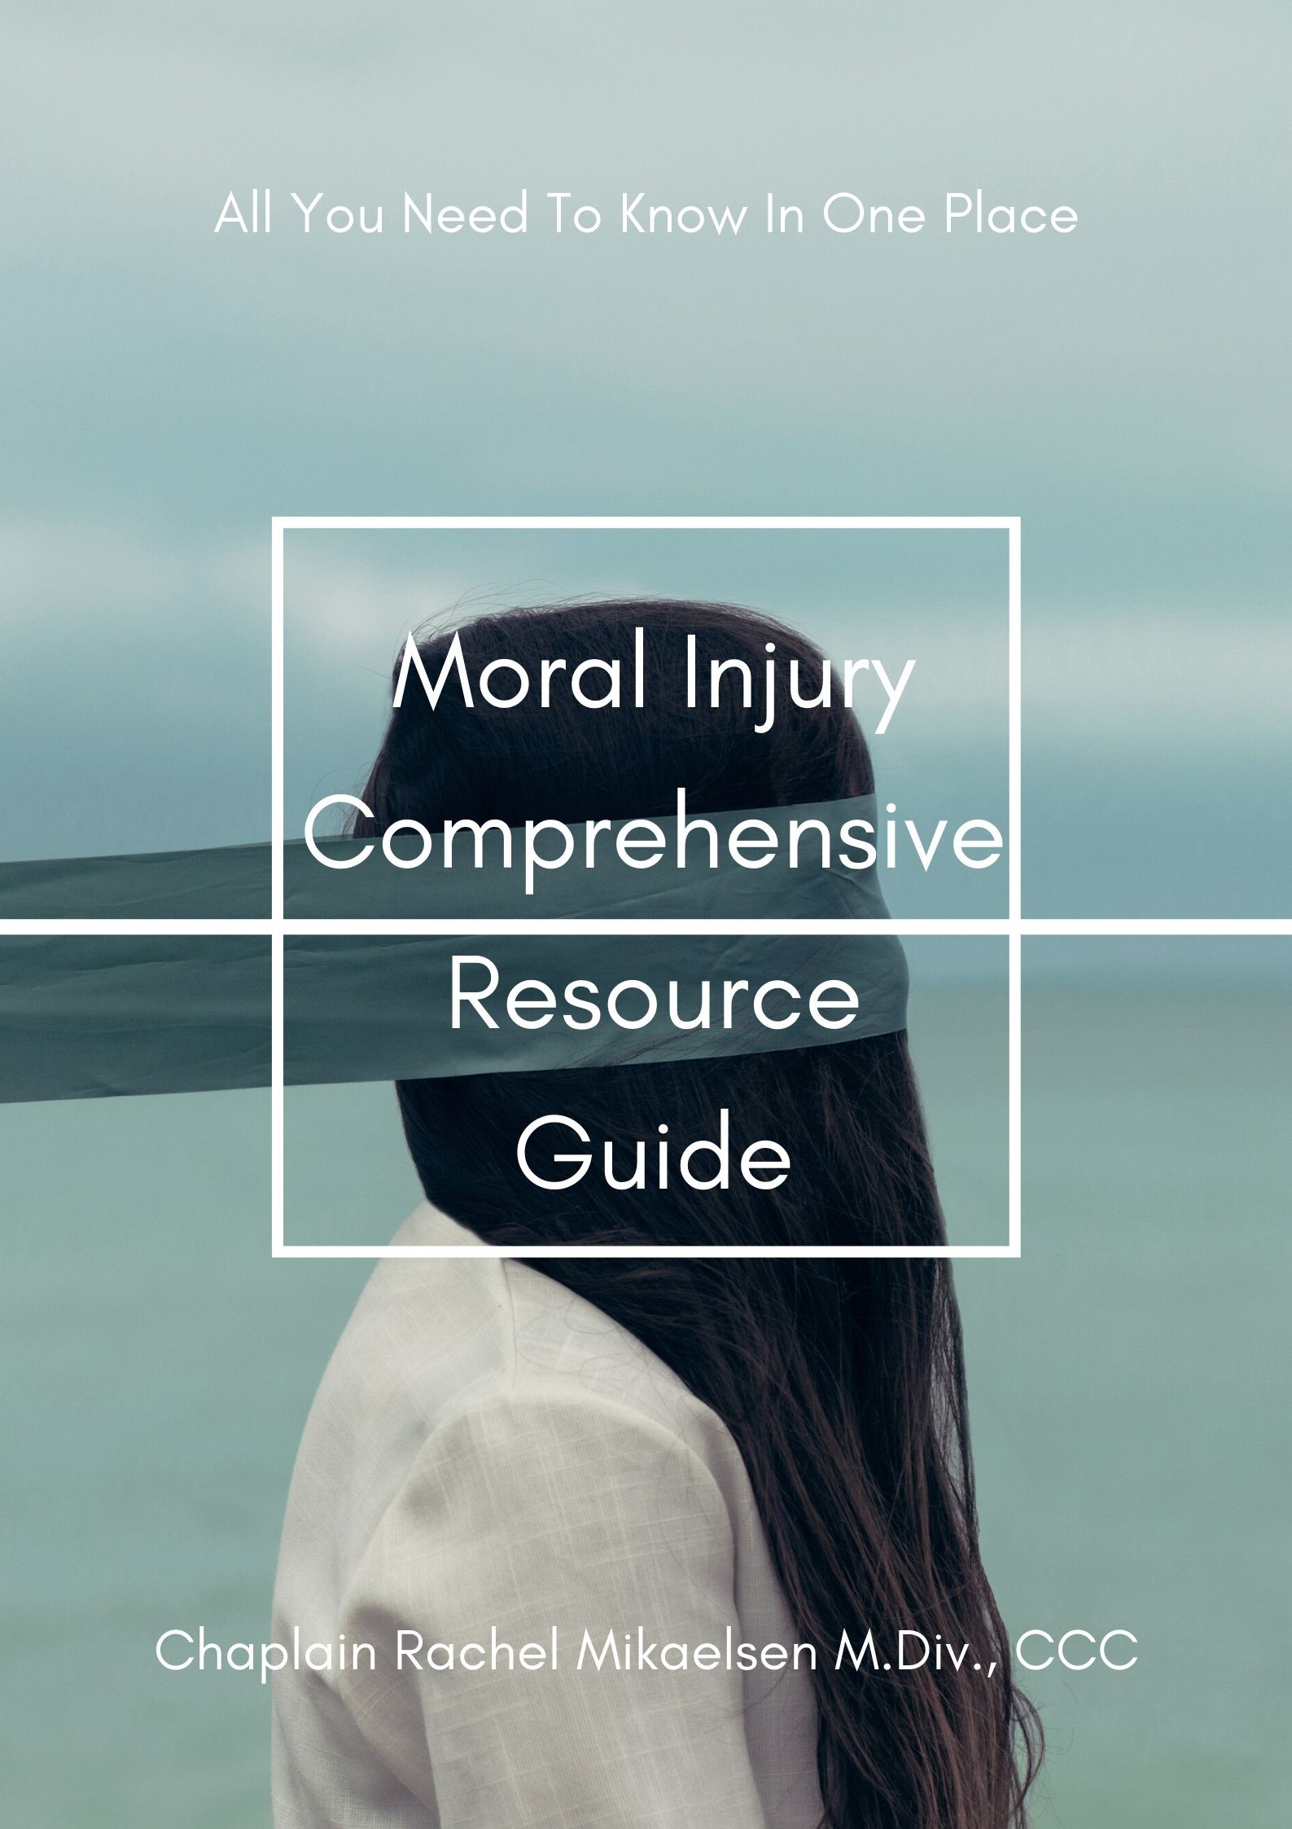

Moral Injury, in its most basic definition is perpetrating, failing to prevent, bearing witness to, or learning about acts that transgress deeply held moral beliefs and expectations. Moral Injury is most often talked about within a Veteran/military context but moral trauma can happen in ANY area of life. You will find that there are several different ways of defining and understanding Moral Injury and in my opinion, no one way is right or wrong. Trauma is complex, humans are complex, therefore the understanding of Moral Injury is also.
As a former Army Chaplain, and current professional mental health chaplain specializing in PTSD, Moral Injury, and trauma, I wanted to create a resource guide that brings together all the information I have gathered over the years. As Moral Injury has become a hot topic within both the pastoral care and mental health professions, there are lots of great scholars and clinicians talking about it.
My sincere hope is that these resources help you to understand a deeply complex experience of trauma known as Moral Injury. As you will see, there is a plethora of information out there and it is all over the place. My goal in creating this guide is so that you no longer have to spend hours and hours searching the internet, research articles, Amazon, and libraries. Some of the resources are free, and many, such as the books, have a cost. In addition, many of the research articles will only be accessible through a site membership via an educational institution, although many local libraries can order articles for you. I am including both Pastoral Care and Mental Health resources because I believe you cannot fully understand Moral Injury unless you study perspectives from both disciplines.

Chaplain Rachel Mikaelsen, M.Div, BCC

Let’s start with the symptoms of Moral Injury:

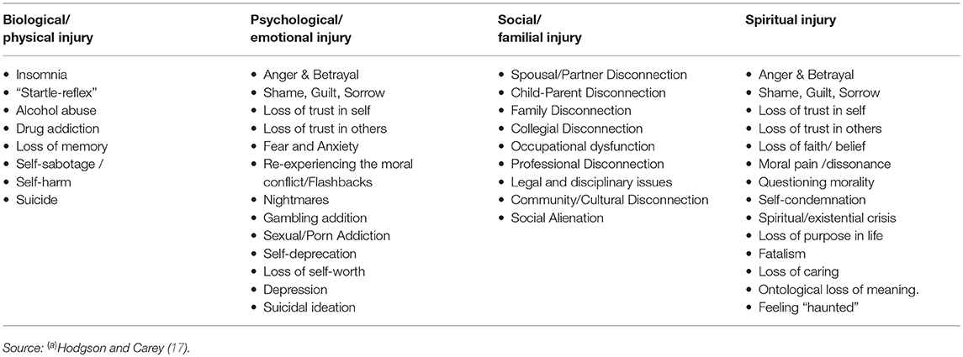

Videos
- Moral Injury: A Working Definition
- Ed Tick on Moral Injury: https://youtu.be/SkTwpMo65HY
- The Veterans Health Administration Chaplain You Tube Series:
    - https://youtu.be/3qb1JTBn7TE
    - https://youtu.be/2zszUCdV7BQ
    - https://youtu.be/w8RlMtLcyAc

- https://youtu.be/L_1PNZdHq6Q
- Dr. William Nash Discusses Moral Injury Beyond the Military Context
- Extending the Concept of Moral Injury Beyond a Military Setting
- Volunteers of America CEO Speaks to the Personal Side of Moral Injury
- Abiathar Carroll Discusses the Concept of Moral Injury
- Moral Injury Affects Healthcare Workers
- https://youtu.be/9kR4KdmYDic

- News Stories
- WLKY 5.2.20 Moral Injury Impacts healthcare workers
- Fox5DC 4.28.20 moral injury impacts healthcare workers during covid19 pandemic
- KTVU – moral injury. 4.9.20
- Coronavirus: Why healthcare workers are at risk of moral injury
- Coronavirus: Health care workers face stress that's 'in many ways equal' to combat

- Books
- Boulanger, Ghislaine (2007). Wounded by Reality: Understanding and Treating Adult-Onset Trauma. Mahwah, NJ: Analytic Press.
- Brock, Rita Nakashima and Lettini, Gabriella (2012). Soul Repair: Recovering from Moral Injury After War. Boston: Beacon Press.
- Courtois, Christine and Ford, Julian D. (2013). Treatment of Complex Trauma: A Sequenced, Relationship-Based Approach. New York: Guilford.
- Doerries, Bryan (2015). All That You’ve Seen Here is God: New Versions of Four Greek Tragedies - Sophocles' Ajax, Philoctetes, Women of Trachis; Aeschylus' Prometheus Bound. New York: Random House.
- Doerries, Bryan (2015). The Theater of War: What Ancient Greek Tragedies Can Teach Us Today. New York: Knopf.
- Epstein, Mark (2013). The Trauma of Everyday Life. New York: Penguin.
- Frankl, Viktor E. (1959/2006). Man’s Search for Meaning. Boston: Beacon Press.
- Herman, Judith (1997): Trauma and Recovery: The Aftermath of Violence – From Domestic Abuse to Political Terror. New York: Basic Books.
- Janoff-Bulman, Ronnie (1992). Shattered Assumptions: Towards a New Psychology of Trauma. New York: Free Press.
- Klay, Phil (2014). Redeployment. New York: Penguin Books.
- Lifton, Robert Jay (1973). Home From the War: Learning from Vietnam Veterans. New York: Other Press.
- Litz, Brett T.; Lebowitz, Leslie; Gray, Matt J.; and Nash, William P. (2015). Adaptive Disclosure: A New Treatment for Military Trauma, Loss, and Moral Injury. New York: Guilford.
- Marlantes, Karl (2011). What It Is Like to Go to War. New York: Atlantic Monthly Press.
- McClelland, Mac (2015). Irritable Hearts: A PTSD Love Story. New York: Flatiron Books.
- Miller, Ronald B. (2004). Facing Human Suffering: Psychology and Psychotherapy as Moral Engagement. Washington, DC: American Psychological Association.
- Morris, David J. (2015). The Evil Hours: A Biography of Post-Traumatic Stress Disorder. New York: Houghton Mifflin Harcourt.
- Schauer, M.; Neuner, F.; and Elbert, T. (2011). Narrative Exposure Therapy: A Short-Term Treatment for Traumatic Stress Disorders. Cambridge, MA: Hogrefe.
- Shay, Jonathan (1995). Achilles in Vietnam: Combat Trauma and The Undoing of Character. New York: Simon and Schuster.
- Shay, Jonathan (2002). Odysseus in America: Combat Trauma and The Trials of Homecoming. New York: Scribner.
- Sherman, Nancy (2015). Afterwar: Healing the Moral Wounds of Our Soldiers. New York: Oxford University Press.
- Sherman, Nancy (2011). The Untold War: Inside the Hearts, Minds, and Souls of Our Soldiers. New York. W W. Norton & Company.
- Sites, Kevin (2013). The Things They Cannot Say: Stories Soldiers Won’t Tell You About What They’ve Seen, Done, or Failed to Do in War. New York: Harper Perennial.
- Stolorow, Robert (2007). Trauma and Human Existence: Autobiographical, Psychoanalytic, and Philosophical Reflections. New York: Routledge.
- Tick, Edward (2005). War and The Soul: Healing Our Nation’s Veterans from Post-Traumatic Stress Disorder. Wheaton, IL: Quest Books.
- Tick, Edward (2014). Warrior’s Return: Restoring the Soul After War. Boulder, CO: Sounds True.
- Van Der Kolk, Bessel (2014). The Body Keeps the Score: Brain, Mind, and Body in the Healing of Trauma. NY: Viking.
- Wood, David (2016). What Have We Done? The Moral Injury of Our Longest Wars. New York: Little, Brown, & Co.

- Movies
- The Best Years of Our Lives (1946) – Combat trauma and moral injury in WW II veterans
- Coming Home (1978) – Combat trauma and moral injury in Vietnam veterans
- The Deerhunter (1978) – Combat trauma and moral injury in Vietnam veterans
- The Accused (1988) – Noncombat PTSD and moral injury from sexual assault
- Born on the Fourth of July (1989) – Combat trauma and moral injury in Vietnam veterans
- Jackknife (1989) – Combat trauma and moral injury in Vietnam veterans
- The Fisher King (1991) – Noncombat PTSD
- The Prince of Tides (1991) – Adult effects of childhood trauma, moral injury (suicidality)
- Schindler’s List (1993) – Noncombat moral injury
- The War at Home (1996) – Combat trauma and moral injury in Vietnam veterans
- Missing in America (2005) – Combat trauma and moral injury in Vietnam veterans
- Gran Torino (2008) – Combat trauma and moral injury in Korean War veterans
- In the Valley of Elah (2008) – Combat trauma and moral injury in OED/OIF/OND veterans
- Brothers (2009) – Combat trauma and moral injury in OED/OIF/OND veterans
- Manchester by the Sea (2016) – Noncombat moral injury
- Three Billboards Outside Ebbing, Missouri (2017) – Noncombat moral injury

- Articles
- Brock, Rita Nakashima (2018). The Link Between Moral Injury & Veteran Suicides. The Washington
- Ano, G. G., & Pargament, K. I. (2012). Predictors of spiritual struggles: An exploratory study. Mental Health, Religion & Culture, 16, 419 – 434.doi:10.1080/13674676.2012.680434
- Ano, G. G., & Vasconcelles, E. B. (2005). Religious coping and psychological adjustment to stress: A meta-analysis. Journal of Clinical Psychology, 61, 461480.doi:10.1002/jclp.20049
- Batson, C. D., & Schoenrade, P. A. (1991). Measuring religion as Quest:I. Validity concerns. Journal for the Scientific Study of Religion, 30,416 – 429. doi:10.2307/1387277
- Beck, R., & McDonald, A. (2004). Attachment to God: The Attachment to God Inventory, tests of working model correspondence, and an exploration of faith group differences. Journal of Psychology and Theology,32, 92–103.
- Bentler, P. M. (1990). Comparative fit indexes in structural models. Psychological Bulletin, 107, 238 –246. doi:10.1037/0033-2909.107.2.238
- Bentler, P. M., & Bonett, D. G. (1980). Significance tests and goodness of
- fit in the analysis of covariance structures. Psychological Bulletin, 88,588 – 606. doi:10.1037/0033-2909.88.3.588
- Brock, Rita Nakashima (2019). The Battle Inside.
- Boulanger, Ghislaine (2008). Witness to Reality: Working Psychodynamically With Survivors of Terror. Psychoanalytic Dialogues, 18, 638-657.DOI: 10.1080/10481880802297673.
- Caplan, Paula J. (2018) Moral Anguish is not a Mental Illness.
- Carr, Russell B. (2011). Combat and Human Existence: Toward an Intersubjective Approach to Combat-Related PTSD. Psychoanalytic Psychology, 28(4), 471-496. DOI: 10.1037/a0024174.
- Currier, Joseph M.; Holland, Jason M.; Drescher, Kent; and Foy, David (2015). Initial Psychometric Evaluation of the Moral Injury Questionnaire – Military Version. Clinical Psychology and Psychotherapy, 22, 54-63. DOI: 10.1002/cpp.1866.
- Currier, Joseph M.; Holland, Jason M; and Malott, Jesse (2015). Moral Injury, Meaning-Making, and Mental Health in Returning Veterans. Journal of Clinical Psychology, 71(3), 229-240. DOI:10.1002/jclp.22134.
- Drescher, Kent D.; Foy, David W.; Kelly, Caroline; Leshner, Anna; Schutz, Kerrie; and Litz, Brett (2011). An Exploration of the Viability and Usefulness of the Construct of Moral Injury in War Veterans. Traumatology, 17(1), 8-13.DOI: 10.1177/1534765610395615.
- Drescher, Kent D. and Foy, David W. (2008). When They Come Home: Post-Traumatic Stress, Moral Injury, and Spiritual Consequences for Veterans. Reflective Practice: Formation and Supervision in Ministry, 28, 85-102.
- Drescher, Kent D.; Nieuwsma, Jason A.; and Swales, Pamela J. (2013). Morality and Moral Injury: Insights from Theology and Health Science. Reflective Practice: Formation and Supervision in Ministry, 33, 50-61.
- Eileen A. Dombo PhD LICSW , Cathleen Gray PhD LICSW & Barbara P.
Early PhD LCSW (2013) The Trauma of Moral Injury: Beyond the Battlefield, Journal of Religion &Spirituality in Social Work: Social Thought, 32:3, 197-210, DOI: 10.1080/15426432.2013.801732
To link to this article: https://doi.org/10.1080/15426432.2013.801732
- Farnsworth, Jacob K.; Drescher, Kent D. ; Evans, Wyatt; and Walser, Robyn D. (In Press). A Functional Approach to Understanding and Treating Military-Related Moral Injury. Journal of Contextual Behavioral Science. DOI: 10.1016/j.jcbs.2017.07.003.
- Farnsworth, Jacob K.; Drescher, Kent D.; Nieuwsma, Jason A.; Walser, Robyn B.; and Currier, Joseph M. (2014). The Role of Moral Emotions in Military Trauma: Implications for the Study and Treatment of Moral Injury. Review of General Psychology, 18(4), 249-262. DOI: 10.1037/gpr0000018
- Frankfurt, Sheila & Frazier, Patricia (2016). A Review of Research on Moral Injury in Combat Veterans. Military Psychology, 28(4) DOI: 10.1037/mil0000132.
- Gray, Matt J., Schorr, Yonit; Nash, William; et al. (2012) Adaptive Disclosure: An Open Trial of a Novel, Exposure-Based Intervention for Service Members with Combat-Related Psychological Stress Injuries. Behavior Therapy, 43, 407-415.
- Haidt, J. (2007). The new synthesis in moral psychology. Science,316, 998–1002.
- Haidt, J., & Graham, J. (2007). When morality opposes justice: Conservatives have moral intuitions that liberals may not recognize.Social Justice Research, 20(1), 98–116.
- Hamlin, J. K. (in revision). Failed attempts to help and harm: Intention guides 8-month-olds’ social evaluations. Manuscript in revision.
- Hamlin, J.K., Mahajan, N., Liberman, Z., & Wynn, K. (2012). Not like me = bad: Infants prefer those who harm dissimilar others.Manuscript submitted for publication
- Amidon, Amy D.; Lang, Ariel J.; and Litz, Brett T. (2015). Treating War-Related Moral Injury and Loss with Adaptive Disclosure: A Case Study. In Ritchie, Elspeth C. Posttraumatic stress disorder and related diseases in combat veterans. New York: Springer.
- Koenig HG, Boucher NA, Oliver JP, Youssef N, Mooney SR, Currier JM, Pearce MP (2017). Rationale for spiritually-oriented cognitive processing therapy for moral injury in active duty military and veterans with post-traumatic stress disorder. Journal of Nervous and Mental Disease, 205(2):147-153 (institutional access only)
- Koenig HG, Youssef NA, Ames D, Oliver JP, Teng EJ, Haynes K, Erickson ZD, Arnold I, Currier JM, O’Garo KN, Pearce MJ (2018). Moral injury and religiosity in U.S. veterans with PTSD symptoms. Journal of Nervous and Mental Disease, in press (institutional access only).
(https://insights.ovid.com/pubmed?pmid=29494381)
- Litz, Brett T.; Stein Nathan; Delaney, Eileen; Lebowitz, Leslie; Nash, William P.; Silva, Caroline; and Maguen, Shira (2009). Moral Injury and Moral Repair in War Veterans: A Preliminary Model and Intervention Strategy. Clinical Psychology Review, 29, 695-706.
- Maguen, Shira and Litz, Brett (2012). Moral Injury in Veterans of War. PTSD Research QuarterlyPTSD Research Quarterly, 23(1), 1-6.
- Maguen, Shira; Burkman, Kristine; Madden, Erin; Dinh, Julie; Bosch, Jean; Keyser, Jessica; Schmitz, Martha; and Neylan, Thomas C. (2017). Impact of Killing in War: A Randomized, Controlled Pilot Trial. Journal of Clinical Psychology, 73(9),997-1012.
- Marek S. Kopacz, Mary S. Adams, Robert Searle, Harold G. Koenig & Craig
J. Bryan (2018): A Preliminary Study Examining the Prevalence and Perceived Intensity of MorallyInjurious Events in a Veterans Affairs Chaplaincy Spiritual Injury Support Group, Journal of HealthCare Chaplaincy, DOI: 10.1080/08854726.2018.1538655
To link to this article: https://doi.org/10.1080/08854726.2018.1538655
- Nash, William P.; Carper, Teresa L. Marino; Mills; Mary Alice; Au, Teresa; Goldsmith, Abigail; and Litz, Brett T. (2013). Psychometric Evaluation of the Moral Injury Events Scale. Military Medicine, 178(6):646-652.
- Nieuwsma, Jason A.; Walser, Robyn D.; Farnsworth, Jacob K.; Drescher, Kent D.; Meador, Keith G.; and Nash, William P. (2015). Possibilities within Acceptance and Commitment Therapy for Approaching Moral Injury. Current Psychiatry Reviews, 11, 193-206.
- Norman, Sonya B.; Wilkins, Kendall C.; Meyers, Ursula S.; and Allard, Carolyn B. (2014). Trauma Informed Guilt Reduction Therapy with Combat Veterans. Cognitive Behavioral Practice, 21(1), 76-88.
- Pearce, M.J., Haines, K., Wade, N., & Koenig, H.G. (2018). Spiritually-integrated cognitive processing therapy: A new treatment for PTSD and moral injury. Global Advances in Health and Medicine, in press (open access free download)
(http://journals.sagepub.com/doi/full/10.1177/2164956118759939)

- Price, June T.; Steuwig, Jeff; and Mashek, Debra (2007). Moral Emotions and Moral Behavior. Annual Review of Psychology, 58, 345-272.DOI: 10.1146/annurev.psych.56.091103.070145.
- Robjant, Katy and Fazel, Mina (2010). The Emerging Evidence for Narrative Exposure Therapy: A Review. Clinical Psychology Review, 30, 1030-1039.
- Youssef NA, Boswell E, Fiedler S, Jump R, Lee E, Yassa M, Khan F, Pathiraja A, Rizk D, Pearce M, O’Garo K, Currier JM, Koenig HG (2018). Moral injury, posttraumatic stress disorder, and religious involvement in U.S. Veterans. Annals of Clinical Psychiatry, in press (forthcoming).
- Volk F, Koenig HG (2018). Moral injury and religiosity in active duty U.S. military with PTSD symptoms. Military Behavioral Health, in press (institutional access only)
(https://www.tandfonline.com/doi/abs/10.1080/21635781.2018.1436102?journalCode=umbh20)

- Vargas, Alison F.; Henson, Thomas; Kraus, Douglas; Drescher, Kent; and Foy, David (2013). Moral Injury Themes in Combat Veterans’ Narrative Responses from the National Vietnam Veterans’ Readjustment Study. Traumatology, 19(3), 243-250.DOI.org/10.1177/1534765613476099.

- Suicide Prevention
- Columbia-Suicide Severity Rating Scale (C-SSRS)
- Marek S. Kopacz, Hugh F. Crean, Crystal L. Park & Rani A. Hoff (2017): Religious Coping and Suicide Risk in a Sample of Recently Returned Veterans, Archives of Suicide Research, DOI: 10.1080/13811118.2017.1390513
- Jaimie Lusk, Steven K. Dobscha, Marek Kopacz, Mary Frances Ritchie & Sarah Ono (2018) Spirituality, Religion, and Suicidality Among Veterans: A Qualitative Study, Archives of Suicide Research, 22:2, 311-326, DOI: 10.1080/13811118.2017.1340856
- Kopacz, M. S., O’Reilly, L. M., Van Inwagen, C. C., Bleck-Doran, T. L., Smith, W. D., & Cornell, N. (2014). Understanding the Role of Chaplains in Veteran Suicide Prevention Efforts A Discussion Paper. Sage Open, 4(4), 1-10. Kopacz_Chaplain_Suicide_Prevention_2014.pdf
- Suicidal behavior and spiritual functioning in a sample of Veterans diagnosed with PTSD. Journal of Injury & Violence Research 2016 Jan, vol. 8(1): 6-14. Doi: 10.5249/jivr.v8i1.728

- Other Sites
- The Moral Injury Project: http://moralinjuryproject.syr.edu/
- Soul Repair Center: https://www.brite.edu/programs/soul-repair/
- VA PTSD website article on moral injury: www.ptsd.va.gov/professional/newsletters/research-quarterly/v23n1.pdf

- Measures
• 45-item Moral Injury Symptom Scale
Koenig HG (2018). Measuring symptoms of moral injury in Veterans and Active Duty Military with PTSD. Religions 9 (3):86 (open access free download, includes full 45- item scale)
(http://www.mdpi.com/2077-1444/9/3/86)
Koenig HG, Ames D, Youssef N, Oliver JP, Volk F, Teng EJ, Haynes K, Erickson Z, Arnold I, O’Garo KN, Pearce M (2018). The Moral Injury Symptoms Scale – Military Version. Journal of Religion and Health 57(1):249-265 (institutional access only)
(https://link.springer.com/article/10.1007%2Fs10943-017-0531-9)
10-item Moral Injury Symptoms Scale- Short Form
Koenig, H.G., Ames D, Youssef N, Oliver JP, Volk F, Teng EJ, Haynes K, Erickson Z, Arnold I, O’Garo KN, Pearce MJ (2018). Screening for Moral Injury – The Moral Injury Symptom Scale-Military Version Short Form. Military Medicine, in press
(https://doi.org/10.1093/milmed/usy017)
(institutional access only; see below for scale)
Koenig, H.G., Youssef NA, Pearce M (2018). Assessment of Moral Injury in Veterans and Active Duty Military with PTSD: A Review of Measures. Frontiers in Psychiatry, in submission
- Responding to Grief, Trauma, and Distress After a Suicide: U.S. National Guidelines
- Humphrey, Karen M. Counseling Strategies for Loss and Grief
- Neimeyer, Robert A. Meaning Reconstruction & The Experience of Loss
- Worden, William J. Grief Counseling and Grief Therapy: A Handbook for the Mental Health Practitioner 4th edition
- Viorst, Judith. Necessary Losses: The Loves, Illusions, Dependencies and Impossible Expectations That All of Us Have to Give Up in Order to Grow
  - Responding to Grief, Trauma, and Distress After a Suicide: U.S. National Guidelines PDF: https://www.sprc.org/sites/default/files/migrate/library/RespondingAfterSuicideNationalGuidelines.pdf
  - Suicide Postvention in the Department of Defense: Evidence, Policies and Procedures, and Perspectives of Loss Survivors PDF: https://www.rand.org/pubs/research_reports/RR586.html
  - Jordan, John. R. Grief After Suicide: The Evolution of Suicide Postvention: https://www.johnjordanphd.com/pdf/pub/Grief%20After%20Suicide%20-%20Evolution%20of%20Suicide%20%20Postvention.....pdf
  - Information and Support After a Suicide Attempt: A Department of Veterans Affair Resource Guide for Family Members of Veterans Who are Coping with Suicidality: https://www.mirecc.va.gov/visn19/docs/ResourceGuideFamilymembers.pdf

Below is a list of mental health specific measures but could also be useful for other care providers in looking at the different approaches to measuring and evaluating a person’s experience of Moral Injury:
